Teams Yearly Expiration and Renewal
Brian Melancon * 01/31/19

Once a year, based on the time of creation, a notification will be sent to Teams’ owner alerting them their Teams account is about to expire.
Email notifications such as the one below are sent to the Teams’ owner 30 days, 15 days, and 1 day prior to expiration of the group.
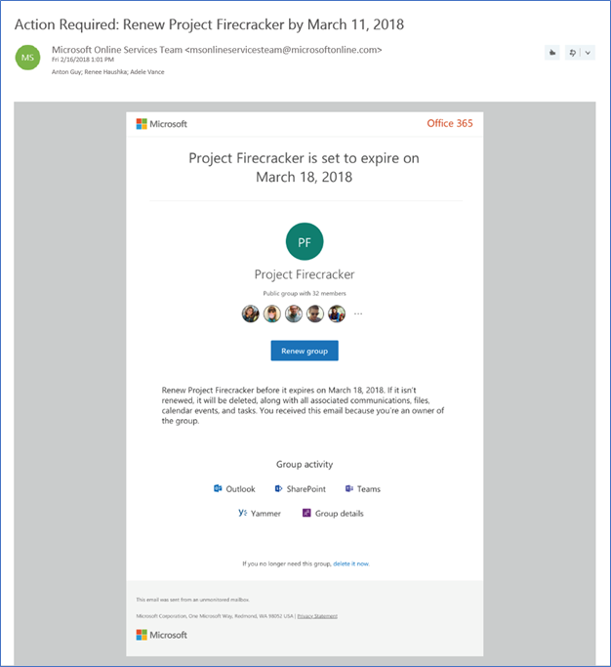
From the Renew group notification email, the Teams’ owner can directly access the group details page in the Access Panel. There, the user can get more information about the group such as its description, when it was last renewed, when it will expire, and also the ability to renew the group.
When a group expires, the group is deleted one day after the expiration date. An email notification such as the one below is sent to the Teams’ owner informing them about the expiration and subsequent deletion of their Teams account.
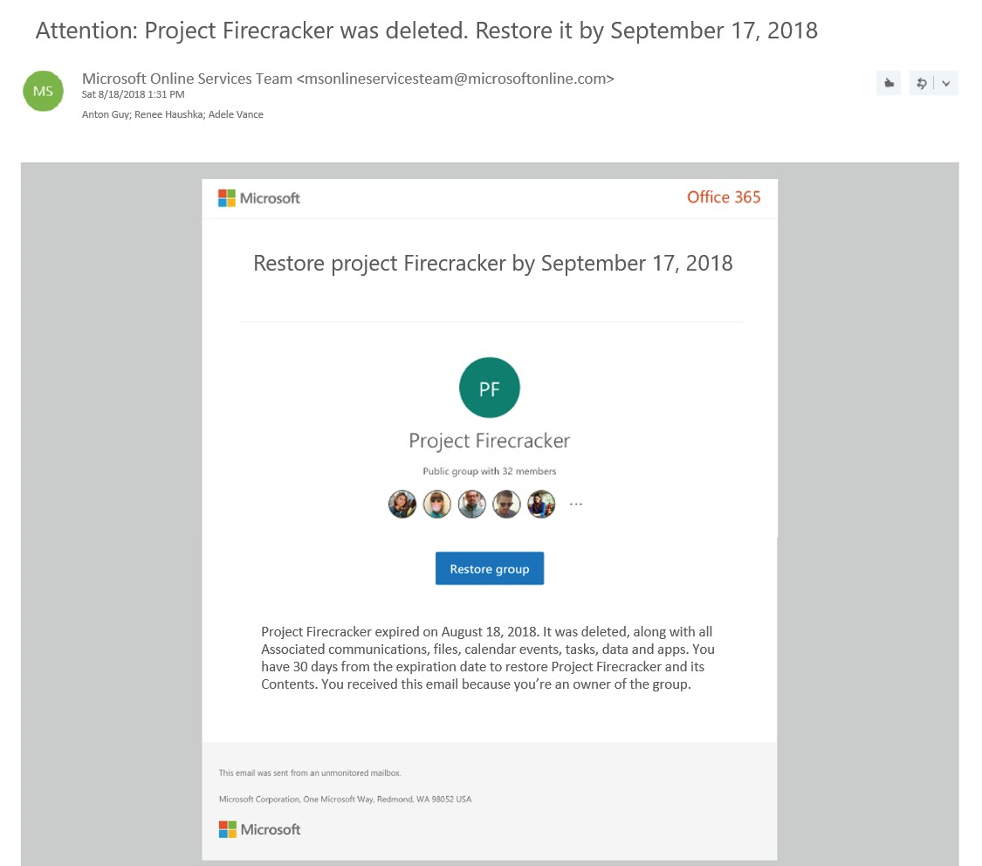
The group can be restored within 30 days of its deletion by selecting Restore or contacting the ITS Service Desk for assistance.
If the group you're restoring contains documents, SharePoint sites, or other content, it might take up to 24 hours to fully restore the group and its contents.

